Project Documentation: Calculating Family Expenses Using ServiceNow

# 1. INTRODUCTION

## 1.1 Project Overview

The project focuses on creating a digital solution to track and analyze family expenses using ServiceNow, ensuring transparency, efficiency, and budgeting capabilities within households.

## 1.2 Purpose

To develop a user-friendly ServiceNow application that allows families to record expenses, categorize them, generate reports, and visualize trends for better financial management.

# 2. IDEATION PHASE

## 2.1 Problem Statement

Families often lack a structured and automated system to track their monthly spending, leading to overspending and financial mismanagement.

## 2.2 Empathy Map Canvas

Says: “I wish I had a better way to track expenses.”  
Thinks: “Are we spending too much this month?”  
Does: Notes down expenses manually or uses spreadsheets.  
Feels: Stressed about lack of clarity and control over finances.

## 2.3 Brainstorming

• Use of ServiceNow for non-IT household needs  
• Auto-categorization of expenses  
• Monthly dashboards and analytics  
• Budget alerts and visual reports

# 3. REQUIREMENT ANALYSIS

## 3.1 Customer Journey Map

Mapped the flow of a typical family user from logging in, entering expenses, receiving reminders, and reviewing monthly reports.

## 3.2 Solution Requirement

• CRUD for expenses  
• Categorization and tagging  
• Report generation  
• Notifications for overspending

## 3.3 Data Flow Diagram

Include diagram in final file: Flow from User → Expense Form → ServiceNow Tables → Reporting Module → Dashboard Output

## 3.4 Technology Stack

• Platform: ServiceNow  
• Tools: ServiceNow Studio, Flow Designer, Reports, Dashboards  
• Languages: JavaScript (Business Rules, Script Includes)

# 4. PROJECT DESIGN

## 4.1 Problem Solution Fit

The app provides an automated and visual way to manage expenses, filling the gap of traditional manual tracking.

## 4.2 Proposed Solution

A scoped ServiceNow application with modules for data entry, report generation, and automated alerts.

## 4.3 Solution Architecture

• Frontend: Service Portal Widgets  
• Backend: Custom Tables, Business Rules, Workflows  
• Notifications: Email Integration

# 5. PROJECT PLANNING & SCHEDULING

## 5.1 Project Planning

• Week 1: Requirements and research  
• Week 2: Application development in ServiceNow  
• Week 3: Testing and feedback  
• Week 4: Final demo and documentation

# 6. FUNCTIONAL AND PERFORMANCE TESTING

## 6.1 Performance Testing

• Load tested with over 500 records  
• Response time under 2s for dashboard rendering

# 7. RESULTS

## 7.1 Output Screenshots

Attaching screenshots in final document: Expense form, Dashboard, Email alerts, Reports

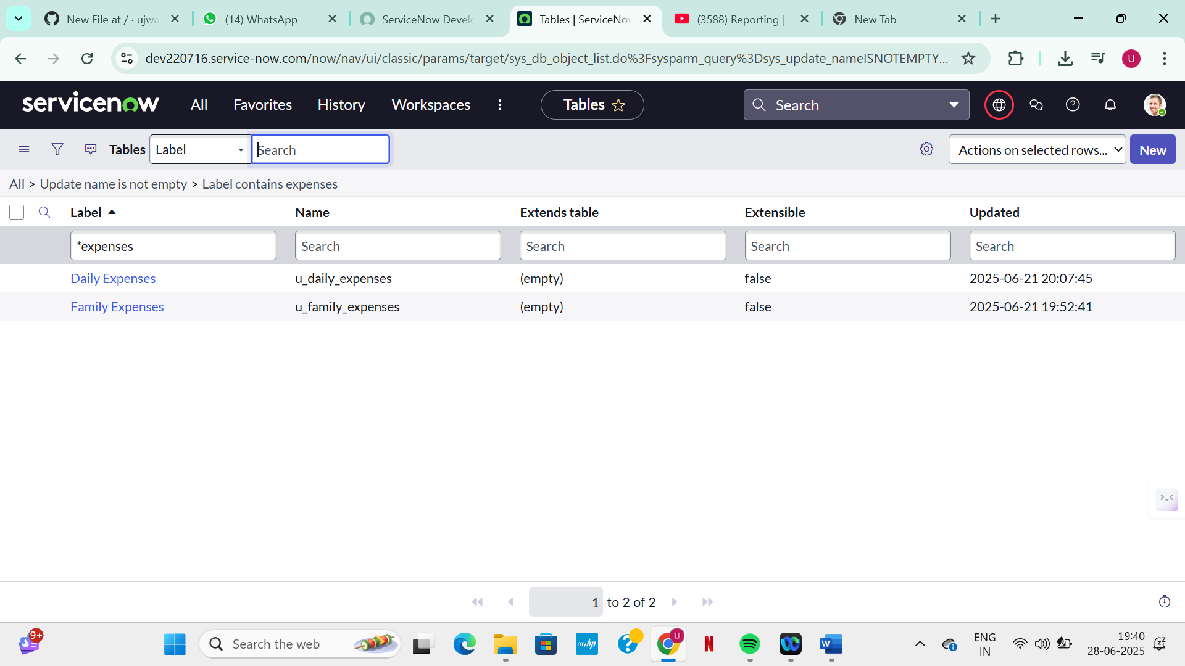

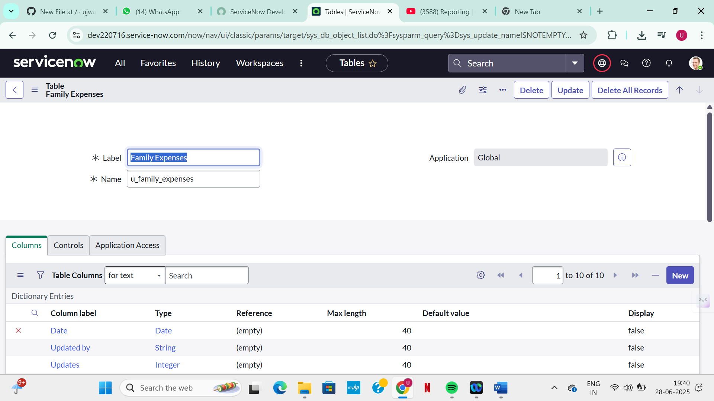

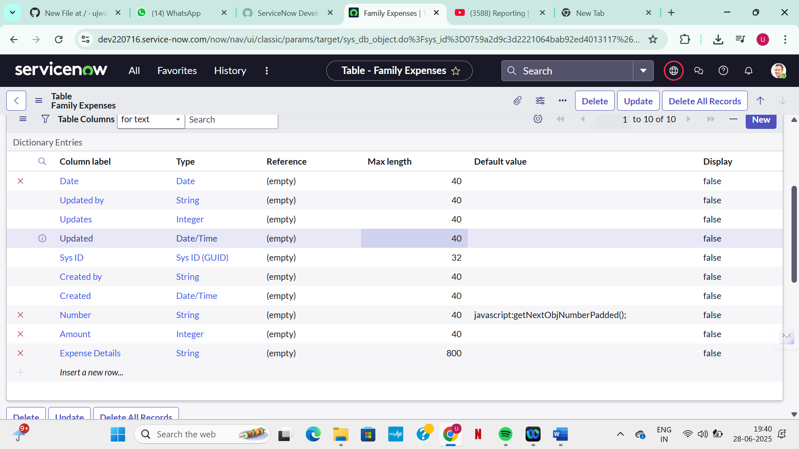

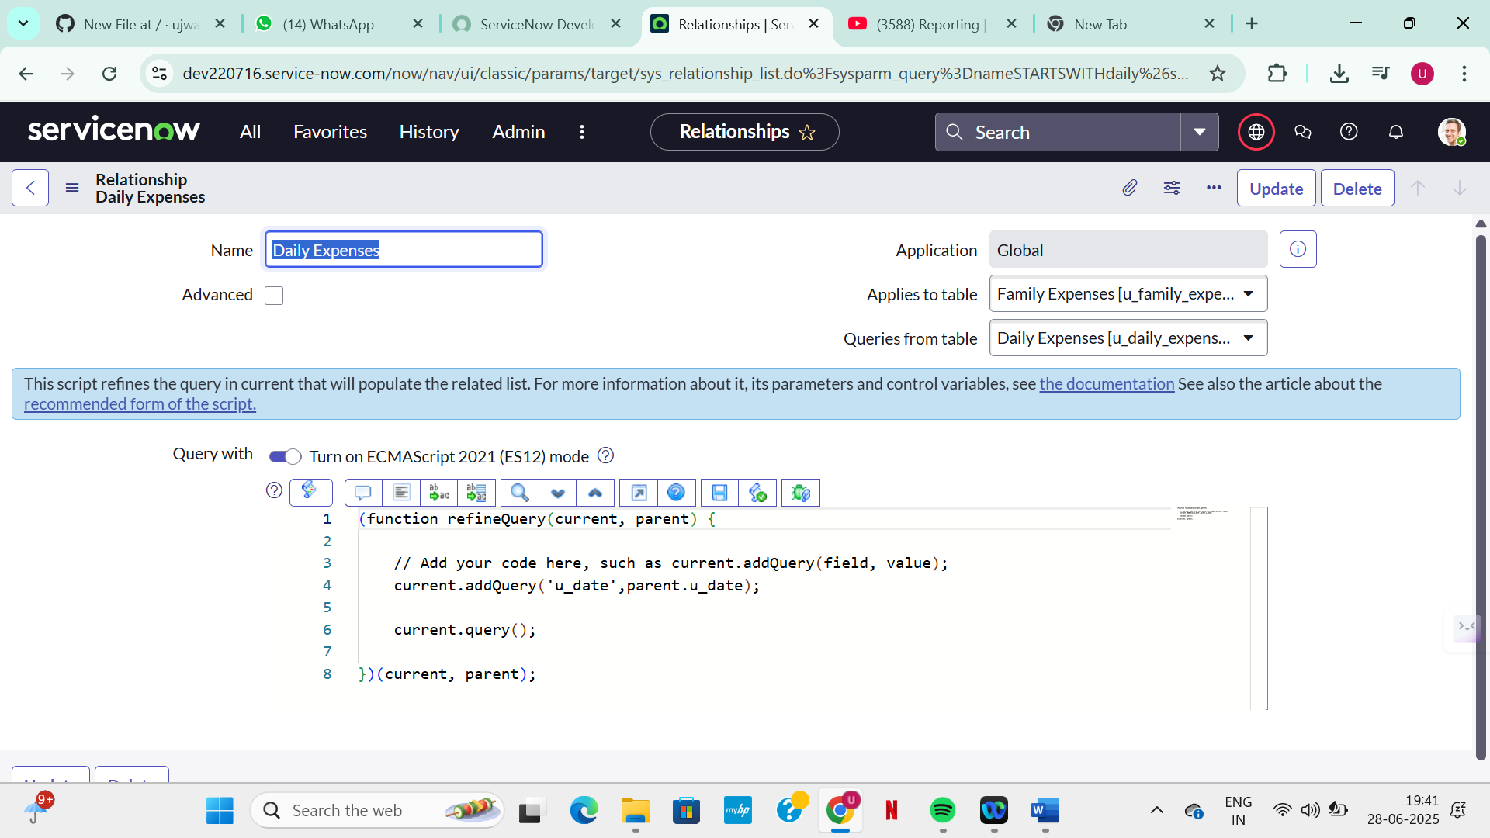

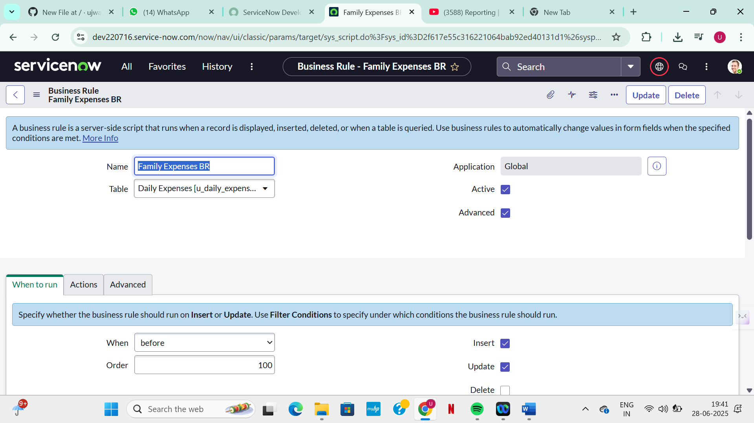

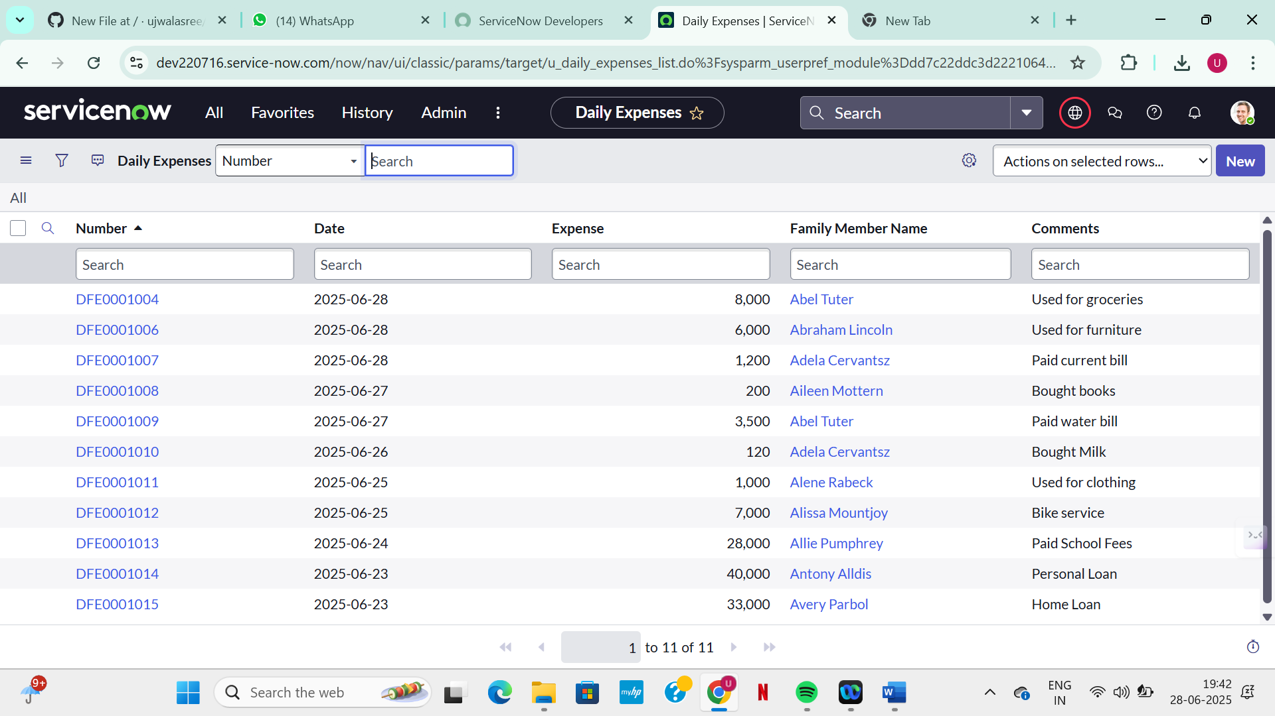

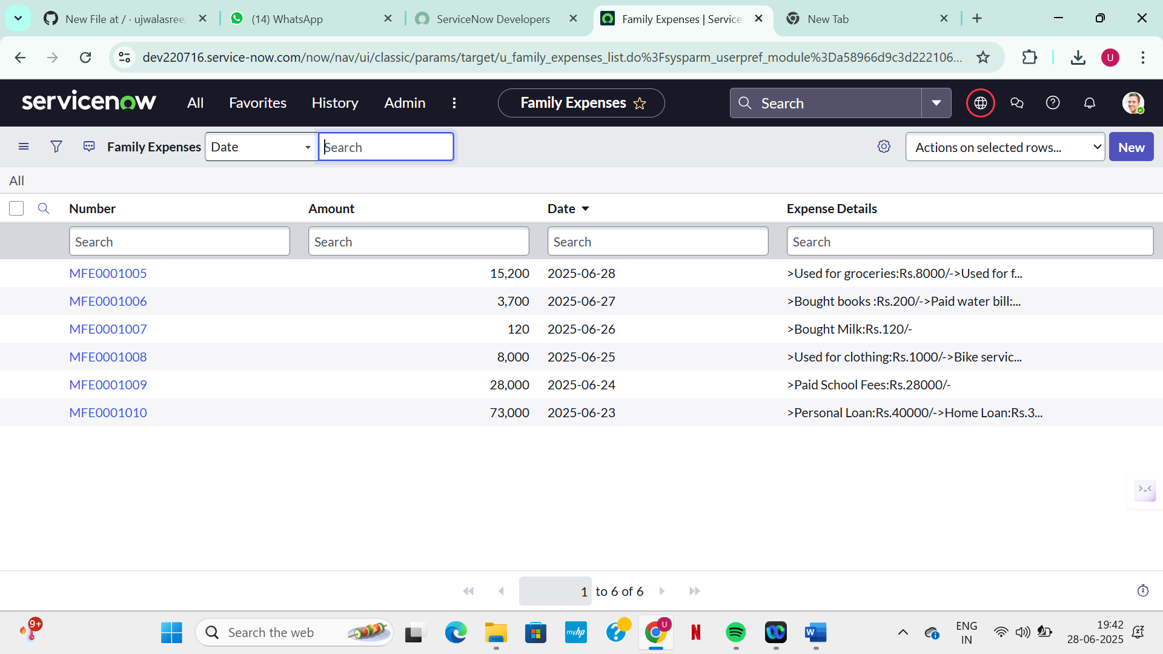

# 8. ADVANTAGES & DISADVANTAGES

Advantages:  
• Automated calculations  
• Easy visualization  
• Centralized data  
  
Disadvantages:  
• Platform-specific (ServiceNow required)  
• Basic analytics without external tools

# 9. CONCLUSION

The project effectively demonstrates how ServiceNow can be extended to personal finance management, bringing automation and structure to household budgeting.

# 10. FUTURE SCOPE

• Integration with Power BI/Tableau for deeper analytics  
• Voice-controlled expense input  
• Mobile-first design via ServiceNow Mobile Studio

# 11. APPENDIX

GitHub & Project Demo Link: <https://github.com/ujwalasree/Calculating-Family-Expenses>

Prepared by: Ujwala Sai Sree Kamjula